**A Comprehensive Data Analysis of Brewery Performance (2017–2019): Analysis with Excel Dashboard**

In an era where informed decision-making stands at the forefront of business strategies, the need for comprehensive data analysis becomes paramount. This report unravels the intricacies of the brewing industry, delving into the realms of profits, brands, and countries.

The dataset under scrutiny is a rich tableau, interwoven with intricate details on brewery brands, consumption metrics, profits derived from sales, the dedicated sales personnel steering these transactions, the diverse countries of operation, and a nuanced categorization based on language and geopolitical zones. This meticulous analysis stretches across a substantial three-year period, spanning from 2017 to 2019.

Embarking on an exploration of the complexities inherent in this expansive dataset, my goal is to craft a narrative that provides a view of the brewing landscape. This report transcends a mere compilation of numbers; it is an expedition into the core of data-driven insights, designed to empower decision-makers with a deep understanding of the dynamics shaping the industry. The undertaking of this project is driven by the aspiration to uncover trends, discern disparities, and reveal potential surprises concealed within the numerical fabric, with the anticipation that the resulting analysis will serve as a guiding compass for those navigating the intricate terrain of the brewing industry. The aim is to steer them toward strategic decision-making rooted in empirical evidence.

**PROJECT GOALS:**

**.** Profit Analysis by years, brands and countries.

**.** Brand Analysis.

**.** Country Analysis.

**.** Recommendations

**PROJECT METHODOLOGY:**

The Steps used in this process include

1· Data Acquisition

2· Data Cleaning

3· Data Analysis & Visualization

**DATA ACQUISITION:**

The dataset was acquired from Edubridge Academy.

It encompasses an XLSX file containing information about Sales Representatives, including their ID numbers and email addresses, as well as details on Brewery Names, Unit Prices, Quantity Consumed, and Profit Generated. Additionally, the dataset provides insights into the Countries where the breweries were sold, their categorization based on geopolitical zones, and a comprehensive time series spanning the 12 months and years from 2017 to 2019.

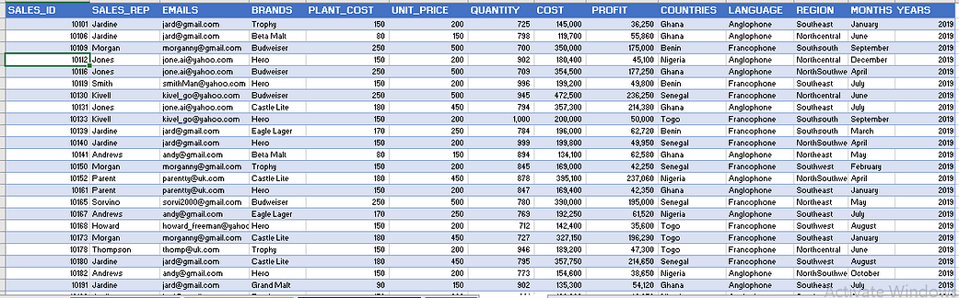

**DATA CLEANING:**

The following data cleansing process were carried out on excel.

1. A VLOOKUP procedure was executed to categorize countries based on language, distinguishing between Anglophone and Francophone regions.
2. Additionally, the data types of columns containing unit price, quantity, cost, and profit were converted from text to numeric formats, enabling their utilization for subsequent calculations.

**DATA ANALYSIS & VISUALIZATION:**

After the data was cleaned, Data validation was used and Pivot tables were created and used in analyzing and summarization of the dataset in line with the business goal.

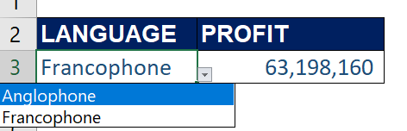

**Profit by territories**

The operational scope of the breweries extends to several countries, namely Ghana, Nigeria, Togo, Senegal, and Benin. These nations are categorized based on language, with Ghana and Nigeria identified as Anglophone, while Togo, Senegal, and Benin are classified as Francophone.

The profits derived from Anglophone and Francophone territories amounted to ₦42,389,260 and ₦63,198,160, respectively, contributing to a total of ₦105,587,420. This distribution represents 40.15% and 59.85%, highlighting the Francophone territory as the most profitable within the three-year period.

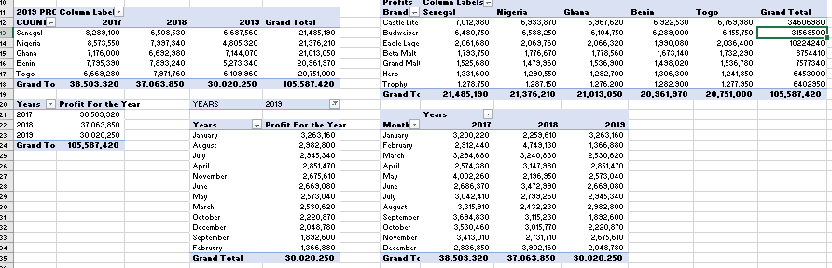

**Profit Analysis**

Further analysis on a monthly basis revealed varying profit trends. In the years 2017, 2018, and 2019, the months of April, May, and February exhibited the least profits, respectively. Conversely, the months of May, February, and January showcased the highest profit generation across the same three-year period.

In addition, within the five-country analysis, the Castle Lite brand demonstrated remarkable profitability, securing the top position in profit generation over the entire three-year duration. Following closely, Budweiser and Eagle Lager claimed the second and third positions, respectively.

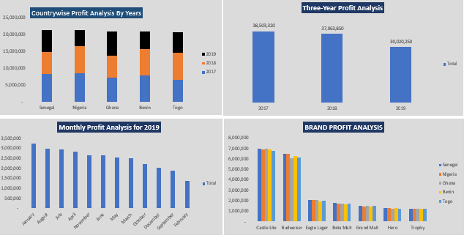

**Profit Analysis Across Diverse Metrics: Graphical Representations**

***Brand Analysis***

An in-depth analysis based on country categorization by language unveiled distinctive brand preferences within Anglophone and Francophone territories throughout the years 2018 and 2019. In 2018, Anglophone territories favored Trophy, Castle Lite, and Budweiser as their top three brands, whereas in 2019, the preferences shifted to Hero, Grand Malt, and Beta Malt. Meanwhile, Francophone territories showcased Beta Malt, Trophy, and Hero as the leading brands in 2018, and Grand Malt, Trophy, and Eagle Lager took precedence in 2019.

This analysis brought to light a significant contrast in Anglophone territories, where beer brands dominated preferences in 2018, giving way to malt brands gaining prominence in 2019. Conversely, Francophone territories consistently displayed a preference for malt brands, securing the top spot in both 2018 and 2019.

Further examination focusing solely on malt brands indicated that Hero and Grand Malt were the preferred choices in Anglophone territories for both 2018 and 2019. In Francophone territories, Beta Malt and Hero led the preferences in 2018, while Grand Malt and Hero claimed the top spots in 2019.

An analysis based on individual countries revealed distinct brand preferences over the three-year period. In Ghana, consumers favored Eagle and Castle Lite. Nigeria exhibited a preference for Budweiser and Eagle Lager. Senegal’s brand preferences leaned towards Hero and Castle Lite, while in Togo, Grand Malt and Trophy were the favored choices. Lastly, in Benin, consumers showed a preference for Hero and Trophy brands.

An in-depth analysis focused on Nigeria revealed prominent brand preferences over the three-year span, with Hero, Castle Lite, and Budweiser emerging as the highest-selling brands in 2019, 2018, and 2017, respectively.

Region-specific examination unveiled distinct preferences across various parts of the country. In the South-South region, Beta Malt, Trophy, and Hero were favored in 2017, 2018, and 2019. The North-Central region exhibited a preference for Trophy, Castle Lite, and Grand Malt. Meanwhile, the North-East favored Castle Lite, Budweiser, and Eagle Lager, and the North-West showed a preference for Eagle Lager, Trophy, and Castle Lite. In the South-East, Grand Malt, Trophy, and Beta Malt were the top choices, while the South-West leaned towards Eagle Lager, Beta Malt, and Grand Malt.

A comprehensive analysis of beer consumption in the country indicated quantities of 41,989 units, 38,378 units, and 23,082 units consumed in the years 2017, 2018, and 2019, respectively. Notably, Budweiser, Castle Lite, Eagle Lager, and Trophy accounted for 26,153 units, 25,681 units, 25,872 units, and 25,743 units, respectively, out of the total consumption of 103,449 units throughout the three-year period.

Further scrutiny of Budweiser consumption highlighted regional variations, with North-Central registering 4,498 units, North-East with 4,320 units, North-West with 4,274 units, South-East with 4,113 units, South-South with 4,328 units, and South-West with 4,620 units over the three-year period.

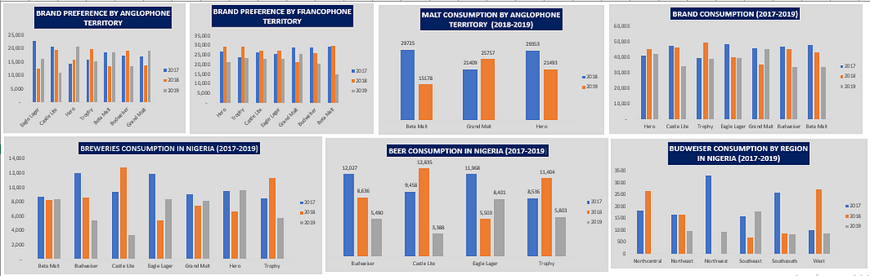

**Brand Analysis**

***Country Analysis***

Among the five countries under consideration, Nigeria emerged as the leader in beer consumption, with a total of 103,449 units, closely followed by Senegal with 103,243 units. Ghana secured the third position with 101,578 units, while Benin and Togo recorded 101,329 and 100,711 units, respectively, in beer consumption.

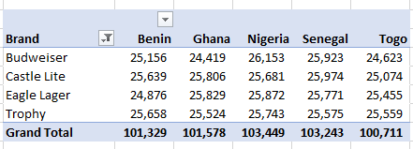

**CONCLUSION:**

In summary, the Francophone territory emerged as the most financially rewarding region over the three-year span, characterized by a notable inclination towards malt brands. Notably, the Castle Lite brand exhibited remarkable profitability, consistently securing the top position in profit generation throughout the entire three-year duration.

The observed decline in brewery profit generation from 2017 to 2019 underscores a nuanced landscape where the brands yielding maximum profits are not uniformly favored across all countries. This disparity reflects the diverse preferences of consumers.

1. **Profit Recovery Strategies for Anglophone Territories:** With both Francophone and Anglophone regions experiencing a decline in profits on a yearly basis in the span of the three years in consideration, the best thing for the stakeholders to do is to put in place some strategies that will help in reversing the trend in both territories. Which might be, cost optimization measures, and enhancing operational efficiency to improve profitability.
2. **Maximizing Profit Margins:** This may involve conducting proper market research, implementing value based pricing, focusing on high-margin products/services, Invest in marketing wisely and use Use a smart pricing tool
3. **Market Focus on Francophone Countries:** Given the higher profit contribution from Francophone countries compared to Anglophone territories over the past three years, it’s recommended to prioritize investment and resource allocation towards strengthening operations and expanding market share in Francophone markets.
4. **Francophone Market Focus:** Given the popularity of Trophy, Hero, and Eagle Lager in Francophone countries over the past two years, it’s recommended to allocate additional resources towards marketing and distribution efforts in these regions. Understanding the preferences and consumption patterns of consumers in Francophone countries can help tailor product offerings and promotional campaigns to maximize market share.
5. **Regional Insights in Nigeria:** Understanding regional consumption patterns, such as Budweiser's dominance in the western region and its surge in the South Eastern region in 2019, can guide localized marketing strategies. Tailoring promotional activities and product offerings to specific regional preferences can enhance brand performance and drive sales growth.
6. **Leverage Brand Success:** With Jones leading in sales volume of the Budweiser brand in Senegal, it’s recommended to analyze the factors contributing to this success. Strategies employed by Jones can be studied and potentially replicated in other markets to enhance brand performance.
7. **Continuous Monitoring and Adaptation:** It’s crucial to continuously monitor market dynamics and consumer preferences in each country and adapt strategies accordingly. Flexibility and agility in response to changing market conditions will be key to maintaining competitiveness and driving growth across all markets.

By implementing these recommendations, International Breweries can optimize their profitability and market presence, increase brand visibility, and drive sales growth across different regions and consumer segments and drive sustainable growth across different regions and product categories.